Section 3 Worker and Targeted Section 3 Worker
Self-Certification (Sample Form)

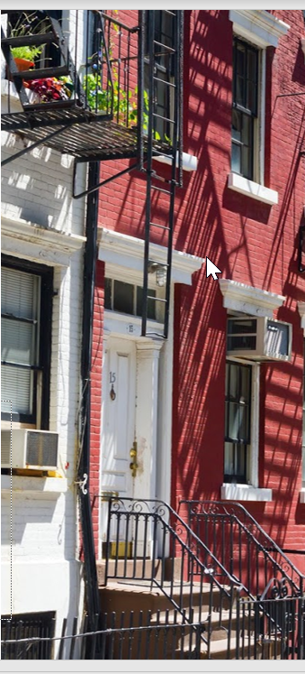
About this Tool
Description: This tool is designed to help grantees and their subrecipients, contractors, and subcontractors comply with the Section 3 requirements and achieve the Section 3 goals. It is intended to be a sample form to help grantees certify and track Section 3 Workers and Targeted Section 3 Workers seeking certification and/or a preference in employment.
How to Adapt this Document: This document is intended to be used as a reference tool to help grantees certify Section 3 workers and provide the appropriate documentation to support the workers’ Section 3 status claims. Grantees are encouraged to adapt the form to fit the resources within their individual communities and to meet the needs of their program.
Source of Document: This document was developed by consultants affiliated with the consulting firm ICF.
Disclaimer: The following is a sample Section 3 Worker and Targeted Section 3 Worker Form that PHAs or Community Development Offices may wish to use to begin developing their own forms. They may work with their legal counsels to ensure it meets all local and state laws.
This resource will be part of a Section 3 Toolkit coming Fall of 2021. It will be hosted on the HUD Exchange at https://www.hudexchange.info/.

Updated as of: December 20, 2021

Section 3 Worker and Targeted Section 3 Worker
Self-Certification (Sample Form)
The purpose of HUD’s Section 3 program is to provide employment, training and contracting opportunities to low-income individuals, particularly those who are recipients of government assistance for housing or other public assistance programs. Your response is voluntary, confidential, and has no effect on your employment.

Eligibility for Section 3 Worker or Targeted Section 3 Worker Status
A Section 3 worker seeking certification shall self-certify and submit this form to the recipient contractor or subcontractor, that the person is a Section 3 worker or Targeted Section 3 Worker as defined in 24 CFR Part 75.
Instructions: Enter/select the appropriate information to confirm your Section 3 worker or Targeted Section 3 Worker status.
Employee Name:

- Are you a resident of public housing or a Housing Choice ☐YES ☐NO
Voucher Holder (Section 8)?
- Are you a resident of the [City/County of insert name] ☐YES ☐NO
- In the field below, select the amount of individual income you believe you earn on an annual basis. *The grantee should confirm that their state and local laws do not prohibit this question.

☐ Less than $10,000 ☐ $30,001 - $40,000 ☐ More than $60,000
☐ $10,001 - $20,000 ☐ $40,001 - $50,000
☐ $20,001 - $30,000 ☐ $50,001 - $60,000

Select from ONE of the following two options below:
I qualify as a:
☐ Section 3 Worker (as defined on page 4 of Section 3 Worker Certification Form)
☐ Targeted Section 3 Worker (as defined on pages 4-5 of Section 3 Worker Certification Form)

(frontside)

Employee Affirmation
I affirm that the above statements (on frontside of this form) are true, complete, and correct to the best of my knowledge and belief. I hereby certify, under penalty of law, that the following information is correct to the best of my knowledge.
Employee Address:
Print Name: Date Hired: _______ Signature: Date:

FOR ADMINISTRATIVE USE ONLY

Is the employee a Section 3 worker based upon their self-certification? □YES □NO

Is the employee a Targeted Section 3 worker based upon their self-certification? □YES □NO

Was this an applicant who was hired as a result of the Section 3 project? □YES □NO

If Yes, what is the name of the company? _______________________

What was the date of hire? _________________

EMPLOYERS MUST RETAIN THIS FORM IN THEIR SECTION 3 COMPLIANCE FILE FOR FIVE YEARS.

(backside)

The City of (insert locality here)

Or

the (insert name here) Housing Authority

Section 3 Income Limits

Eligibility Guidelines
The worker’s income must be at or below the amount provided below for an individual (household of 1) regardless of actual household size.
Individual Income Limits for City of (insert locality here)
FY 20 (insert year here)
Income Limits  Category | FY 20 (enter year here)  Income Limits
Extremely Low Income Limits
(30%)
Very Low Income Limits
(50%)
Low Income Limits
(80%)

See https://www.huduser.gov/portal/datasets/il.html for most recent income limits.

Section 3 Worker Definition:
- A low or very low-income resident (the worker’s income for the previous or annualized calendar year is below the income limit established by HUD); or
- Employed by a Section 3 business concern; or
- A YouthBuild participant.
Targeted Section 3 Worker Definition (for public housing)
- Employed by a Section 3 business concern or
- Currently meets or when hired met at least one of the following categories as documented within the past five years:
  - A resident of public housing; or
  - A resident of other public housing projects or Section 8-assisted housing; or
  - A YouthBuild participant.

Targeted Section 3 Worker Definition (for housing and community development)
- Employed by a Section 3 business concern or
- Currently meets or when hired met at least one of the following categories as documented within the past five years:
  - Living within the service area or the neighborhood of the project, as defined in 24 CFR 75.5
  - A YouthBuild participant.

