EMERGENCY HOUSING VOUCHER (EHV) PROGRAM

Landlord partners are vital to ending homelessness
Emergency Housing Vouchers (EHVs) are a new resource available to individuals or families that meet one of four eligibility categories:
Homeless  - Homeless  - At risk of becoming homeless  - Recently homeless and for whom providing rental assistance will prevent housing instability |  | Survivors  - Fleeing, or attempting to flee, domestic violence, dating violence, sexual assault, stalking, or human trafficking

Advantages of becoming an EHV landlord
- Reliable, on-time rental payments from the housing authority to cover a significant portion of the rent due.
- Housing authority staff are an additional resource for communication between the landlord and the family.
- Regular inspections by the housing authority help protect real estate investments by identifying potential property concerns early.
- Financial incentives for EHV landlords vary by housing authority and could include:
  - Signing bonus for each EHV tenant
  - Security deposit of up to two months of rent
  - Higher EHV payment standards to expand housing opportunity
  - Damage mitigation funds to recover rent loss and damages exceeding the security deposit

Leasing under the EHV program
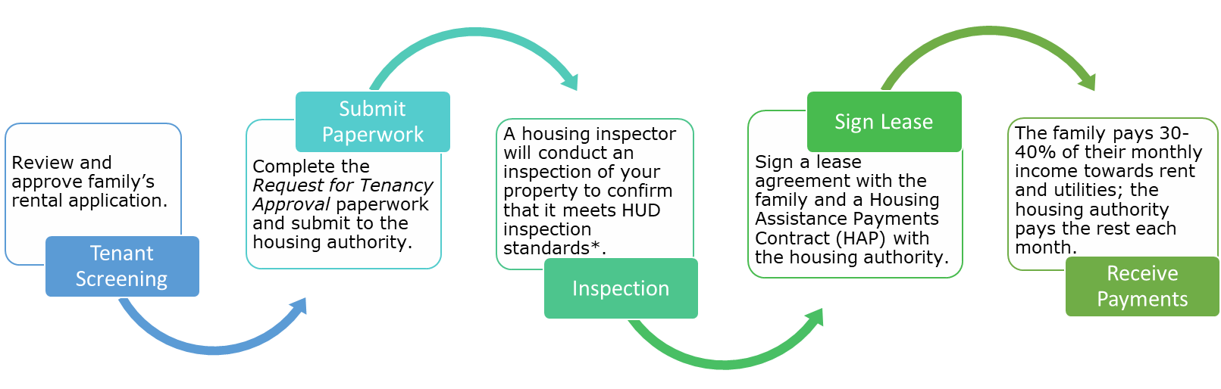
*If your unit has been pre-inspected, this step happens first.

Partner with your local housing authority to house members of your community most in need of decent, safe, and affordable housing.
The EHV Program is made possible by the American Rescue Plan Act and the U.S. Department of HUD.

