mixed-use developer

Request for Qualifications (RFQ)

Tool #3
Description: This is an example of a Request for Qualifications (RFQ) for mixed-use developments. A RFQ can be used by Community Development Block Grant Disaster Recovery (CDBG-DR) grantees to select a developer or developers seeking to create or redevelop commercial and/or mixed-use projects. An RFQ does not seek a bid price or least cost approach to developer selection. Instead it allows the CDBG-DR grantee to select a developer for continued negotiations based on their experience and qualifications in achieving the CDBG-DR grantee’s objectives.
How to Adapt this Document: This document addresses major components of a typical RFQ and represents one approach to selecting private developers to achieve a local government’s redevelopment goals. However, it should not be used as-is. The RFQ contains sections specific to the issuing redevelopment agency, its project and local controlling law. CDBG-DR grantees should determine if the basic RFQ structure meets their underlying program design. Additionally specific attention should be paid to the legal requirements of the grantee. Instructions and advice embedded in the document should be deleted.
Source of Document: Substantial portions of this document come from a specific RFQ drafted for the City of Morgan Hill, Calif.
This document is not an official HUD document and has not been reviewed by HUD counsel. It is provided for informational purposes only. Any binding agreement should be reviewed by attorneys for the parties to the agreement and must conform to state and local laws.
For More Information
This resource is part of the Community Development Block Grant Disaster Recovery (CDBG-DR) Toolkits. View all of the Disaster Recovery Toolkits here: https://www.onecpd.info/resource/2853/cdbg-dr-toolkits.
Community Development Block Grant Disaster Recovery (CDBG-DR) Toolkits are designed to provide general guidance across all types of disasters (e.g. hurricanes, floods; tornadoes; earthquakes; etc.). CDBG-DR Toolkits are NOT disaster specific. CDBG-DR grant funding for a disaster or group of disasters is governed by CDBG requirements and any modifications contained in one or more Federal Register Notices (FRN) applicable to the disaster. Grantees subject to the Disaster Relief Appropriations Act of 2013 (Public Law 113-2) should review all footnotes for additional applicable citations and guidance.
In addition to the FRN, Toolkit users should review applicable Federal cross-cutting requirements. The FRN, as well as cross-cutting requirements, are available on the Department’s website.

For additional information about disaster recovery programs, please see your HUD representative.

U.S. Department of Housing and Urban Development
Community Planning and Development, Disaster Recovery and Special Issues Division

DOWNTOWN OPPORTUNITY QUALIFIED | 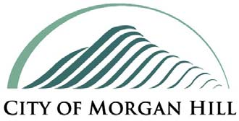 | DEVELOPMENT REQUEST FOR DEVELOPERS
Release Date: September 29, 2009

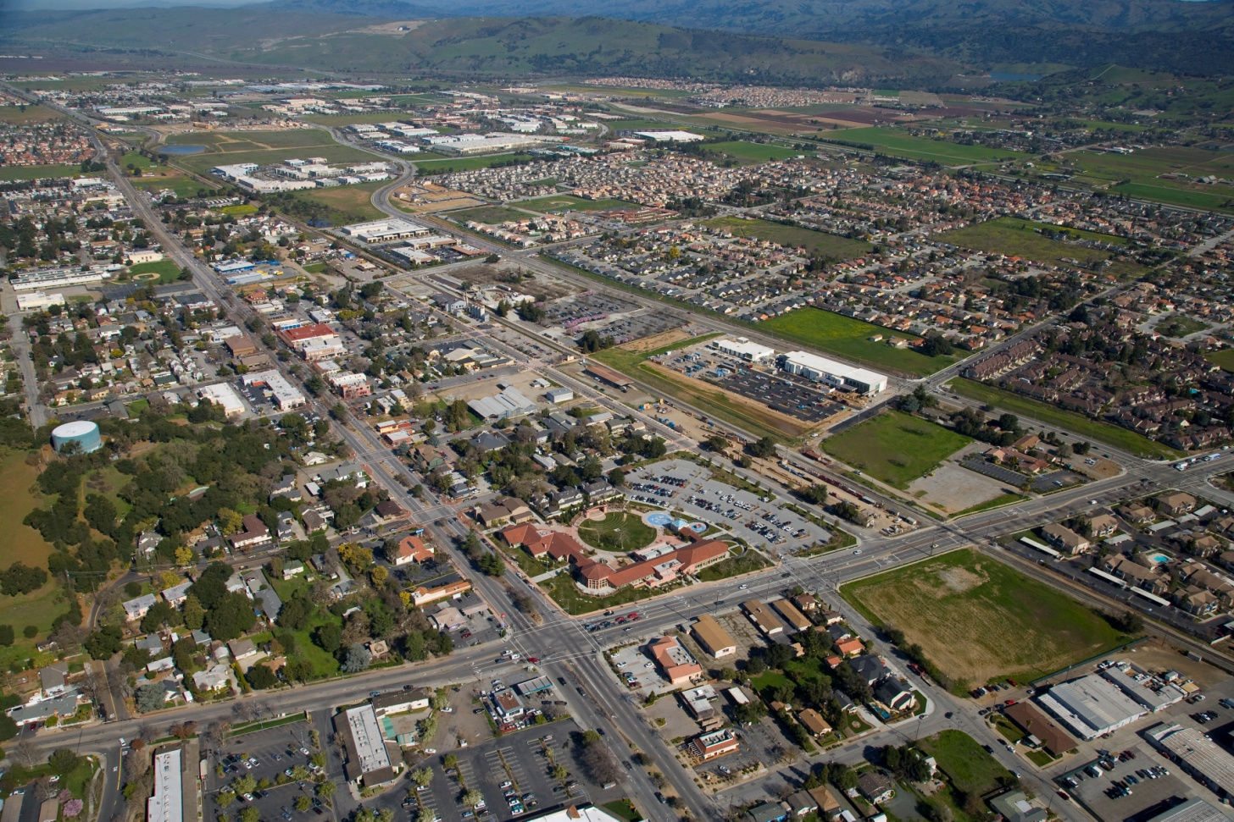
Figure 1 – Downtown Aerial View

Submittals due: December 14, 2009, 4:00 pm PST
Send Submittals, ten (10) hard copies plus one (1) CD electronic copy, to:
City Clerk’s Office City of Morgan Hill 17555 Peak Avenue Morgan Hill, CA 95037

Table of Contents

I. SUMMARY OF OFFERING 6
II. INTRODUCTION 9
A. The Opportunity 9
B. Downtown Goals and Objectives 10
C. Community Engagement 10
D. Recent Milestones 11
E. Developer Role 11
F. Agency Role and Tax Increment 11
III. OVERVIEW 13
A. Regional 13
B. Local 13
C. Santa Clara County Courthouse 14
D. Third Street Promenade 14
E. Market Demographics 15
IV. DOWNTOWN SPECIFIC PLAN AND ENTITLEMENTS 15
A. Downtown Specific Plan (the “Plan”) 15
B. Master Environmental Impact Report 16
C. Residential Development Control System (RDCS) and Voter approved Measure A 16
D. City Processing and Impact Fees 16
E. Association of Bay Area Governments (ABAG) Priority Development Area 16
V. DEVELOPMENT CRITERIA 16
A. Design, Building Height and Bulk, Setback, Ground Floor Retail 16
B. Granada Theater and re-establishment of cinema downtown 17
C. Parking 17
D. Monterey Road Study 18
E. Affordable Housing 18
F. Green Building 18
G. Transit Oriented Development (TOD) 18
H. Floodplain 18
VI. OPPORTUNITY SITES 19
A. Summary 19
B. Block 2: Site A 20
C. Block 3: Site B 23
D. Block 3: Site C 23
E. Block 16: Site D 24
F. Site Assembly 24
VII. OTHER SITE AND PROJECTS DOWNTOWN 24
A. Block 3: 45 East Third Street 24
B. Block 4: Agency-owned property and Sunsweet Site 25
C. Block 7: Weston-Miles 25
D. Block 15: Huntington Square 25
E. Block 18: EAH & South Bay Development 25
F. California High Speed Rail 25
VIII. SUBMITTAL PROCESS: DEADLINE, REQUIREMENTS & REVIEW 26
A. Deadline for Submissions 26
B. Requirements for Submissions 26
1. Transmittal Cover Letter 26
2. Development Team Summary 27
3. Proposed Site or Sites and Project Concept 27
4. Relevant Development Experience and Development Capacity 28
5. Demonstration of Financial Capacity and Related Information 29
6. References 29
C. Submittal Schedule 30
IX. EVALUATION CRITERIA AND SELECTION PROCESS 30
A. Evaluation Criteria 30
B. Selection Process 31
X. POST SELECTION PROCESS AND FUTURE MILESTONES 31
XI. DISCLAIMERS, LIMITATIONS AND WAIVER OF PROTEST 32
XII. CITY CONTACT FOR QUESTIONS 33
XIV. LIST OF EXHIBITS 34
XV. RELATED REFERENCE MATERIALS 34

Table of Figures
Figure 1 – Downtown Aerial View 2
Figure 2 – Site map 8
Figure 3 – Regional & Local Maps 13
Figure 4 – Third Street Promenade 14
Figure 5 – Granada sign and marquee 17
Figure 6 – Downtown Floodplain 18
Figure 7 – Location Map for Opportunity Sites 19
Figure 8 – WRT/Solomon ETC Architects: Maximum Capacity Study 20
Figure 9a – Monterey Road at East First Street (looking southeast) 21
Figure 9b – Monterey Road at East Second Street (looking northeast) – historic Votaw Building on corner 22
Figures 10a and b – Concept Design (Henry Architects) 23

I. SUMMARY OF OFFERING
[This section is introductory. Grantees should describe the basic need and summarize specific development or redevelopment goals for the area based on the grantee’s plans and strategy. ]
The Morgan Hill Redevelopment Agency (the “Agency”) issues this Request for Qualified Developers (the “RFQ”) in order to select a development team to design, finance and build a mixed-use project or projects in downtown Morgan Hill, consistent with the proposed Downtown Specific Plan (the “Plan”).
The Agency has identified four opportunity sites totaling 10 acres that are prime candidates for redevelopment. The Agency owns Sites A and B and has a minority interest in Site D. A summary of these four sites is on the next page. Although this RFQ is intended to solicit developer interest in any or all of these sites, the Agency has identified Site B as the most likely first phase project given current market conditions, and especially given the Agency’s first-phase desire to re-establish cinema entertainment in downtown.
[Can be adjusted to describe other neighborhood(s) serving commercial development objective.]
Responding developers are encouraged to select the site or sites that they consider best suited in their judgment for a start of construction in 2011 with completion in 2012. Responders are free to suggest multiple sites and phases, as the total potential value of downtown development could range from $10 million to more than $200 million.
The Agency has taken steps to create a positive, pro-active development environment including:
• Flexible zoning via a revised Specific Plan (adoption in November 2009)
• Environmental clearance via a companion Master EIR (certification in November 2009)
• Exemption from the residential development controls via a 500-unit exemption (May 2009)
For projects within the Plan’s parameters, only a Design Permit and Building Permit would be required, once site control has been secured. Developers should therefore anticipate reduced predevelopment risk and costs, as well as more certainty as to project time-to-market.
MINIMUM SUBMISSION REQUIREMENTS
[Potential developers will need to know the minimum requirements to submit a proposal. Otherwise their submittal could be rejected.]

The Agency has attempted to minimize the submittal requirements in order to maximize the prospect of receiving your submittal. Only basic information concerning the Development Team, Proposed Site and Project Concept, Relevant Experience and Capacity, Financial Capacity, and References is required. This RFQ does not require submittal of detailed information such as a site plan, floor plans, elevation studies and renderings, financial proformas or completely defined development team.
This RFQ is to identify a developer to complete the first phase project. Responders must (1) clearly identify the first phase site, (2) explain why this site was chosen, and (3) provide the necessary information to confirm the ability to complete the project.
The Agency looks forward to receiving your proposal.
OPPORTUNITY SITES AND PROPERTY SUMMARY
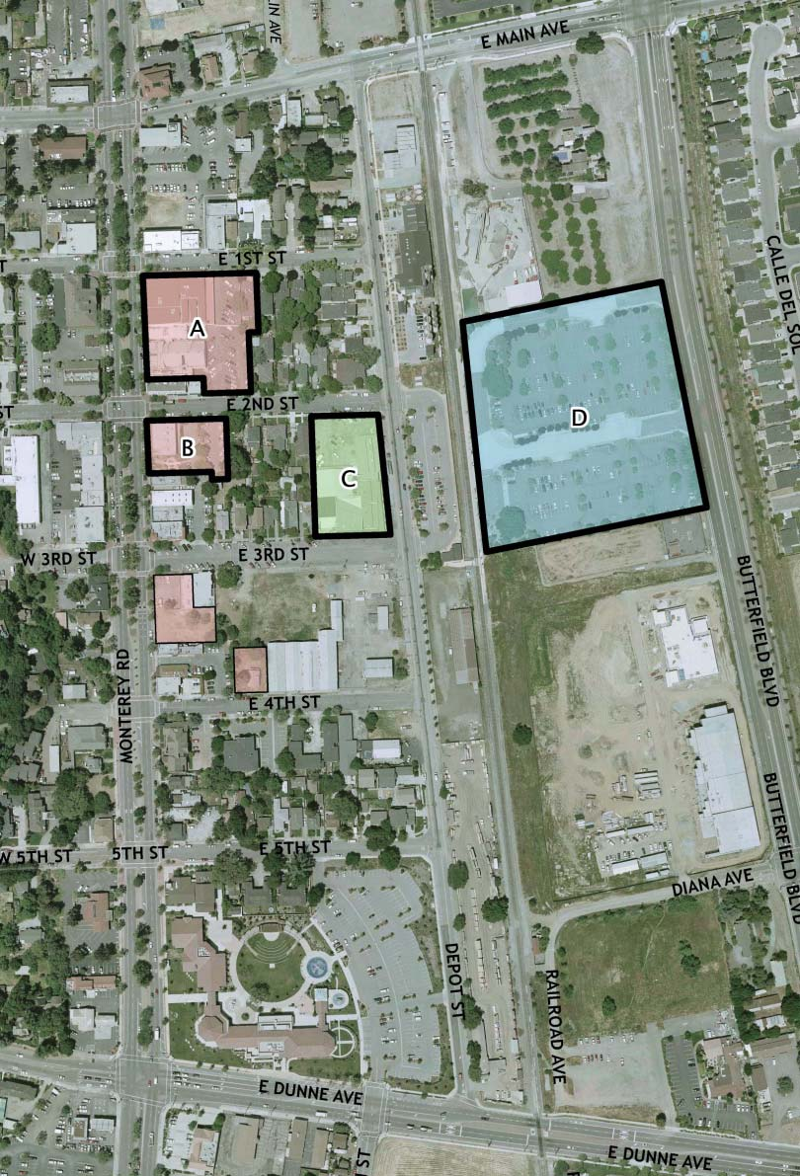
Figure 2 – Site map

[Site maps help orient developers unfamiliar with the community.]

II. INTRODUCTION
[This section begins the detailed part of the RFQ.]

A. The Opportunity

The RFQ process invites prospective developer teams to submit their qualifications as well as a summary of their vision and implementation strategy for development of one or more of the available opportunity sites. The Agency is seeking feedback through this RFQ process as to what mixed-use components may be most feasible, and a vision of how a proposed mix of uses (retail, entertainment, office, residential, parking) would look and function in conjunction with other downtown land uses.
Following receipt, the responses of all applicants will be reviewed for completeness and analyzed based upon the criteria described in the RFQ. Depending upon the number of submittals, the Agency may request some or all developer respondents to make one or more presentations as part of the selection process.
If there are a sufficient number of responses, or in the event of responses for Site D (Block
16: VTA), the Agency will consider undertaking the additional step of a Request For Proposals (RFP) process prior to selecting a developer candidate. The RFP process will allow the Agency to select a short list of responding developers, who will be invited to submit more detailed proposals. Final developer selection will be subject to approval by the Agency Board.
The selected developer candidate will then be presented to the Agency Board for approval of an Exclusive Negotiating Agreement (ENA) followed by negotiation in the case of Agency-owned property of a Disposition and Development Agreement (DDA), or in the case of privately-owned property, an Owner Participation Agreement (OPA), once the developer has demonstrated the necessary site control. Any ENA, DDA or OPA must be approved by the Morgan Hill Redevelopment Agency Board.
A | 1.47 | Agency | retail, residential and parking | Retail, residential
B | 0.51 | Agency | retail, parking and pocket park | Cinema, retail, public parking | Also potentially office space
C | 1.08 | Private | retail and parking | Retail, residential | Also potentially office space; must secure site control
D | 6.89 | VTA / Agency | parking for commuter rail | Residential, commuter parking | Potential office &/or retail also; must secure site control

B. Downtown Goals and Objectives
In 1981, Morgan Hill completed a Downtown Plan to address issues raised by the completion of U.S Highway 101, which shifted the bulk of north-south traffic off of Monterey Road. Many of the recommendations in the 1981 Plan were implemented, but over time a consensus formed that more could be done. In 2003, a citizen task force created the framework for a 2003 Downtown Design Plan, but this plan was accepted instead of adopted by the City Council to forestall the need to prepare an Environmental Impact Report. In 2007 a further update was initiated and this effort culminated in the July 2008 release of the draft Downtown Specific Plan, which addresses increased residential density, standards for new commercial spaces, a coordinated parking strategy, examination of circulation patterns, and creation of a plan for public investment.

The Specific Plan details the City’s desire to invigorate the central city place where people can shop, work, meet, and gather and to stimulate economic vitality in a way that supports existing businesses as well as adds new businesses that meet resident’s and visitor’s needs. A key objective is to further invigorate Morgan Hill’s quaint downtown into a more vibrant, identifiable area with a diverse mix of uses emphasizing specialty retail, restaurant, entertainment, residential and commuter serving uses. An additional important companion objective is to capture more local dollars that now are spent in retail businesses outside Morgan Hill.

The vision for downtown is a district that boasts an active, pedestrian scene and festive atmosphere that attracts both tourists and locals, provides a destination and gathering place for the community, offers a diversity of workforce housing opportunities, preserves existing viable businesses as an integral part of the downtown, and provides a compact and pedestrian friendly streetscape.
The key focus of the project is creation of a vital retail and pedestrian presence downtown which supports downtown residential development.
The Agency has identified the target components of a desired first phase project to include
(a) A 3 or 4 screen cinema with 300 to 500 seats (b) 4,000 to 6,000 square feet of ground floor retail space, and (c) some portion of the on-site parking set aside for public use.
Please refer to the Plan for a more complete description of City goals and objectives.

C. Community Engagement
[Essential to let prospective developers know your expectations for community outreach as part of the project.]

Morgan Hill has a tradition of an actively engaged community deeply interested in the future of Downtown and the community at large. The selected developer will be expected to implement a community outreach program to solicit community input and consensus on the project.

D. Recent Milestones
[Good section to list CDBG-DR planning efforts and strategic planning.]
In February 2009, the Agency Board authorized an 11-point Implementation Plan for downtown, which included pursuing re-establishment of cinema in downtown at Site B and the temporary re-opening of the existing Granada Theater on an interim basis.
In May 2009, the Agency Board directed staff to pursue an Exclusive Negotiation Agreement with CineLux Theatres Co. LLC to serve as the operator of the new cinema at Site B as well as the temporary operator of the existing Granada cinema until such time as the new cinema is completed. In June 2009, the Agency Board reviewed and commented on a conceptual design of a mixed-use retail, cinema, office and residential project on Site B.

In July 2009, the Agency Board authorized up to $310,000 to make the necessary temporary repairs to the existing Granada for its proposed interim use, once negotiations with CineLux to operate the interim and new facility were completed.

E. Developer Role
[Key section where the role of the developer is stated.]
The selected developer will lead negotiations with the Agency for completion of an ENA and a DDA or an OPA (depending on whether the site is Agency-owned or privately-owned), engage the necessary design and other consultants necessary to define the project, complete the design and secure the necessary permits, secure equity and debt financing, contract for and construct the project, and own and manage the project after completion.
The Agency has not ruled out the potential for selecting either a master developer for downtown, or different developers for different sites, notwithstanding additional issues that may arise should this approach be pursued.

F. Agency Role and Tax Increment
[Similar to above – key section where the role of the public agency / CDBG-DR grantee is stated.]
In 1981, the Morgan Hill City Council adopted the Ojo de Agua Redevelopment Project Area. In November 2006, the City Council and Morgan Hill Redevelopment Agency Board approved the 4th amendment to the Redevelopment Plan which allowed for an increase to the limit of tax increment that the Agency may receive up to $580 million.
In 2008, the Agency issued $110 million in tax allocation bonds. The Agency has committed $40 million to facilitate downtown development either through land acquisition or public infrastructure improvements. In 2008, the Agency also acquired several downtown properties in an effort to assemble key parcels to facilitate development. These properties included the Downtown Mall/Granada Theater (Site A) and Royal Clothiers/Christopher Travel (Site B) as well as parcels for new parking lots. The Agency Board also placed special emphasis on downtown development by creating a new position, Assistant to the City Manager for Downtown Revitalization.
Of the $40 million committed to downtown, over $21 million remains for downtown infrastructure and development. Morgan Hill’s Five-Year Capital Improvement Plan (FY 2009-10 to FY 2013-14) budgets over $16.7 million for infrastructure projects in downtown in areas such as street improvements, street lighting, and public parking improvements. The source of downtown funding is a combination of bond proceeds and annual tax increment.
Subject to terms developed in future negotiations, the Agency desires to sell the sites it has assembled (Sites A and B), and assist with the development of sites that are owned by others.

[The next sections can be as detailed or limited as needed to convey the context for the project.]

III. OVERVIEW

A. Regional

The City of Morgan Hill is located approximately 12 miles south of San Jose (Silicon Valley), 10 miles north of Gilroy and 15 miles from the Pacific Coast. San Francisco is approximately 70 miles to the north and the Monterey Peninsula is about 50 miles to the south.
The City is centered on U.S. Highway 101, which is the major north-south regional transportation corridor. Downtown Morgan Hill is located about 25 miles south of the San Jose International Airport and 55 miles south of San Francisco International Airport.
Figure 3 – Regional & Local Maps
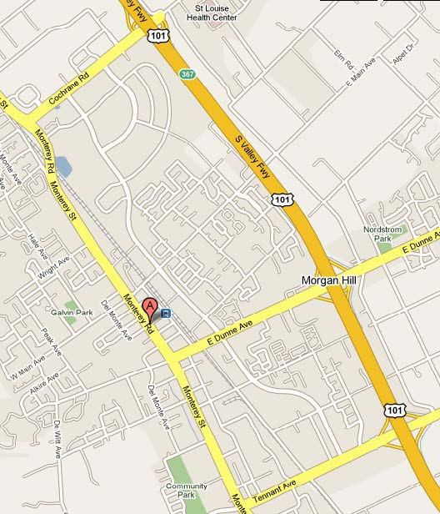 | 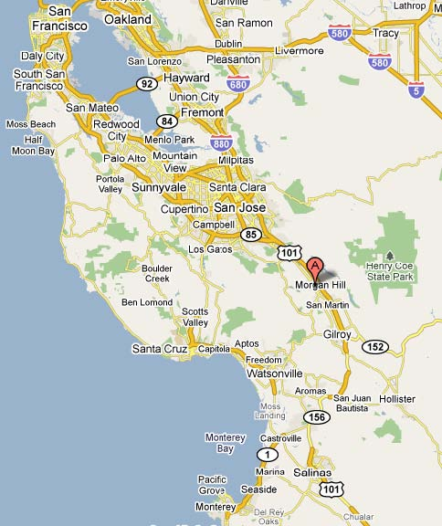

B. Local
Downtown Morgan Hill is centered on Monterey Road, the original Spanish El Camino Real which spanned California from San Diego to San Francisco. The Union Pacific Railroad Line parallels Monterey Road just east of Depot Street and provides commuter rail service between Gilroy and San Francisco from the station at East Third Street.
There are three exits from U.S Highway 101 serving Morgan Hill with the Dunne Avenue exit approximately 1 mile from the center of downtown (Monterey Road and Third Street).

C. Santa Clara County Courthouse
In April 2009, a Santa Clara County Superior Courthouse opened on an eight acre site in downtown. This modern facility consists of four state-of-the-art courtrooms and will serve south Santa Clara County residents for many future decades. The Court building is approximately 73,000 square feet. The companion 17,000 square foot office building provides space for District Attorney, Public Defender and Juvenile Justice staffs and attorneys.

D. Third Street Promenade
A total re-construction of East Third Street between Monterey Road and Depot Street will complete a vision that reaches back to the founding of the City of Morgan Hill in 1906. The downtown street grid set East Third Street at an 80-foot right-of-way in contrast with the remaining east-west street pattern which is set at a 60-foot right-of-way. East Third Street was envisioned as the main commercial corridor linking Monterey Road and the train station. With the assistance of an MTC grant, this road project is currently 50% through the final phase of construction and is targeted for completion by the end of this year. The site plan for the new street is shown below.
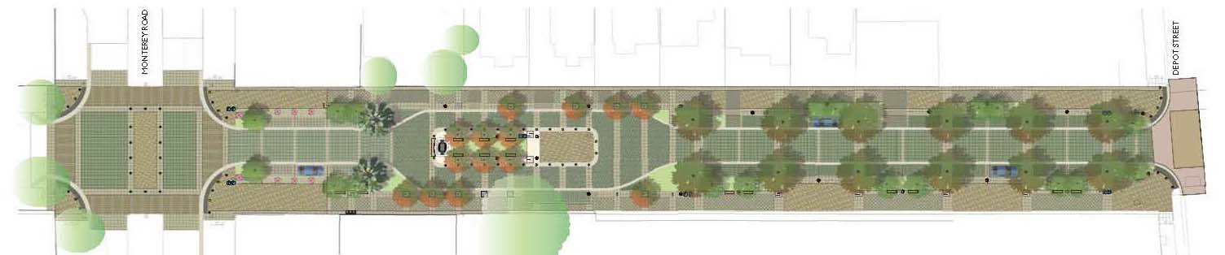
Figure 4 – Third Street Promenade

The new spectacular Third Street Promenade includes 23-foot and 18-foot wide sidewalks to allow for an active streetscape for outside dining and other compatible uses; a central focal-point grove with water-feature, seating and bandstand area; a single drive lane in each direction; parallel parking; and a textured landscape plan with multiple tree varieties and locations. The Promenade will have an open “plaza-like” feeling throughout, given the flat street cross-section with no curbs and the use of a series of different pavers instead of more traditional surfaces. The Promenade is designed to allow for up to 4 different closure configurations based on the size and scope of an event. Major events in downtown include Taste of Morgan Hill; Mushroom Mardi Gras; December Holiday Parade and Tree Lighting Ceremony; Fourth of July Parade and Festivities; Friday Night Music Series; Saturday Certified Farmers Market and Downtown Safe Halloween.

E. Market Demographics
Morgan Hill’s population is approximately 39,800 within a south Santa Clara County / San Benito County sub-region of approximately 150,000. Santa Clara County’s population is approximately 1.85 million. The 12-county greater San Francisco Bay Area / Monterey Bay Area population is over 8.1 million, making it the fourth largest US metropolitan area. In 2030, Morgan Hill is estimated to have a population of 55,600.
Notwithstanding Morgan Hill’s close proximity to Silicon Valley, causing many residents to commute north each day, Morgan Hill has a significant, growing and diverse mixture of businesses primarily in its 3 major business centers. One of these centers, Morgan Hill Ranch, ranks as the second largest business center in Silicon Valley. In 2008, there was an average of over 16,000 jobs in Morgan Hill, with the largest employment sector being manufacturing (approximately 3,200 employees), followed by wholesale trade and professional, scientific, technically-skilled positions.
Downtown Morgan Hill has approximately 11,000 residents within a 1 mile radius, 38,000 within a 3 mile radius and 49,000 within a 5 mile radius. In 2008, Morgan Hill’s 12,950 households had an average household income of $134,000.
More detailed demographic information is available with the Reference Materials.

IV. DOWNTOWN SPECIFIC PLAN AND ENTITLEMENTS

A. Downtown Specific Plan (the “Plan”)

The Plan, which covers an area of 115 acres in 20 blocks, is located entirely within the Ojo de Agua Redevelopment Project Area. The Plan includes proposed changes to existing and planned land uses, circulation, parking, urban design guidelines, signage guidelines, infrastructure and implementation plans. The chart below details the expected new and total development envisioned through 2015 and 2030. By 2015, the Plan has identified potential development of as many as 850 net new dwelling units, 21,221 square feet of net new retail space and 30,157 square feet of net new office / service space.
 | Current | 2015 net new | 2015 Total | 2030 net new | 2030 Total
Dwelling Units | 201 | 850 | 1,051 | 1,192 | 1,393
Retail (sf) | 213,365 | 21,221 | 234,586 | 93,490 | 306,855
Office/ Service (sf) | 122,248 | 30,157 | 152,405 | 85,591 | 207,839

B. Master Environmental Impact Report
The draft Master Environmental Impact Report (the “MEIR”) for the Plan was released on July 31, 2009. The proposed Plan and final MEIR are targeted for adoption and certification, respectively, by the City Council in November 2009. When certified, the MEIR is intended to provide CEQA clearance for any downtown project consistent with its analysis.

C. Residential Development Control System (RDCS) and Voter approved Measure A
Development of new residential dwelling units in Morgan Hill is guided by the Residential Development Control System (RDCS), originally passed in 1977 and amended on three subsequent occasions. Over the past 30+ years the RDCS has resulted in a range of 200 to 250 dwelling units being constructed each year in Morgan Hill, with the majority of these units being single family detached homes. On May 19, 2009, Morgan Hill voters approved Measure A, which allows for development of up to 500 dwelling units in the Plan area without completing the RDCS competition process.

D. City Processing and Impact Fees
Downtown projects are exempt from City sewer impact fees. All other standard City fees apply, including but not limited to Design Review, impact and building permit.

E. Association of Bay Area Governments (ABAG) Priority Development Area
In October 2008, the City received designation as a Priority Development Area (PDA). The PDA designation enables local governments to apply for specialized technical assistance, planning grants and capital funding from the State and other agencies for infill development projects that offer housing and transportation choices for all residents, while helping to reduce traffic, protect the environment, and enhance existing neighborhoods. The Association of Bay Area Governments (ABAG) administers this program entitled “FOCUS”, the regional development and conservation strategy for the San Francisco Bay Area.

V. DEVELOPMENT CRITERIA
[If the site or project has specific development criteria, describe them. If the developer will create those per their design development process, then describe that requirement here instead.]

A. Design, Building Height and Bulk, Setback, Ground Floor Retail
Please refer to the Plan, not this summary, for complete details of the Plan’s requirements.
Design that preserves and enhances the character and pedestrian scale of downtown will be a critical component of development. The downtown grid pattern was created with individual lots on a 40-foot width and developers will be encouraged to mirror that pattern in any new building, especially as all of the identified opportunity sites have street frontages well in excess of 40 feet.
The Plan defines building bulk through a Floor-to-Area ratio (FAR) methodology. The Plan allows for FAR 2.0 with a maximum of three floors, and in the case of sites in excess of 22,000 square feet, a 2.25 FAR with a maximum of 4 floors – with the 4th floor stepped back. Building setbacks for commercial development are zero with maximum heights of 45 feet for three-stories and 55 feet for four-stories (to the roof-plate). The Plan also allows, on a case-by-case basis with submittal of a Planned Development (PD) application, for higher density on some sites.
The Plan mandates a Ground Floor Overlay district (GFO) on Monterey Road and the Third Street Promenade (see attached Exhibit G). Occupants within the GFO district would be restricted to retail shops, restaurants, entertainment uses, and service commercial businesses that support a continuity of display window visual interest. The required minimum depth of retail spaces along Monterey Road is 60 feet and along East Third Street is 50 feet. The minimum height for all ground floor retail spaces is 14 feet (floor-to- floor)

B. Granada Theater and re-establishment of cinema downtown
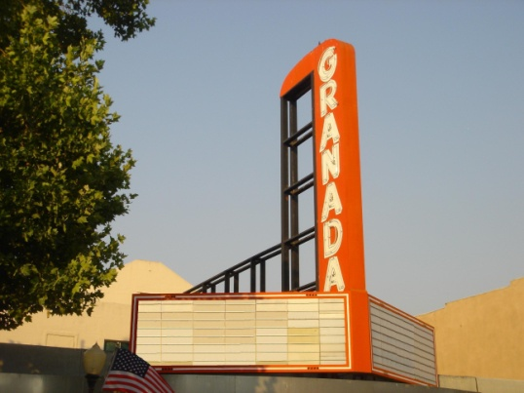
Figure 5 – Granada sign and marquee
The Agency Board has designated re-establishment of cinema in downtown as a first phase goal. The existing downtown cinema – the Granada Theater - closed in September 2003, leaving Morgan Hill with one cinema complex at the Tennant Station Shopping Center. The operator of the Tennant Station 11-plex is CineLux Theatres Co. LLC (“CineLux”). CineLux has expressed interest in operating a cinema downtown and assisted in the design development of the conceptual project designed with Henry Architects for the Agency-owned Site B. This concept design includes a four-screen second–floor cinema with 477 seats plus ground floor retail and upper floor office spaces. CineLux’s letter of interest is attached as Exhibit H. The City Council has designated the Granada sign and marquee as important to preserve, and therefore, these components must be incorporated into a downtown project (see Figure 4).

C. Parking
The Plan requires on-site parking for dwelling units only, on a sliding scale; 1 space for units 600 square feet or smaller; 1.5 spaces for units greater than 600 and less than 1,350; and 2 spaces for units 1,350 square feet or larger. No visitor or commercial parking is required on-site as the Plan commits the City / RDA to create the necessary commercial and visitor parking in public lots. The Agency recently completed two public parking lots: 92-spaces at Depot and East Third Streets, and 17 spaces on Monterey Road between East Third and East Fourth Streets. The Agency has also purchased properties on Monterey Road between Main and West First Streets, and on East Third Street to create new or expanded public parking facilities. Agency-owned sites between Depot Street and the railroad tracks have been identified as potential locations for parking structures that might accommodate 600 to 800 public parking spaces. Additional resources include the Community and Cultural Center parking lot (at Monterey Road and Dunne Avenue) and potentially the Courthouse parking lot for larger weekend and evening events and festivals.
Figure 6 – Downtown Floodplain
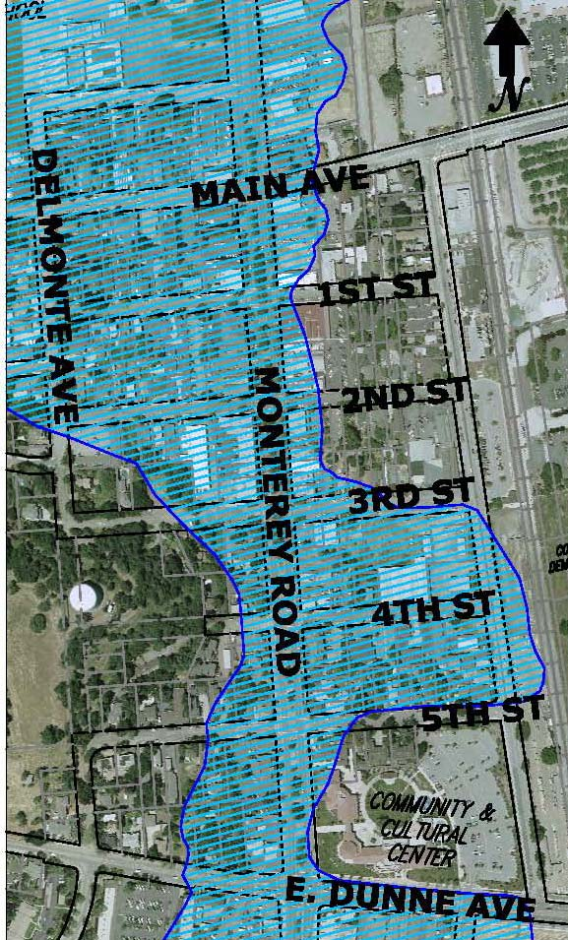

D. Monterey Road Study
The City has released a draft Environmental Impact Report updating the General Plan Circulation Element. The EIR provides information about the possibility of narrowing Monterey Road to reduce the travel lanes from 4-lanes to 2-lanes in order to create opportunities for wider sidewalks, additional parking and landscaping.

E. Affordable Housing
The Plan does not mandate that any new downtown development designate any new dwelling units as affordable and it is possible that both rental and for-sale units may be “affordable by design”. The Agency is nevertheless open to proposals that provide various levels of affordability as part of a development financing program. While the Agency is not encouraging deed restricted affordable housing on Sites A & B (on the Monterey Road), the Agency is open to proposals for Site D (the VTA/Caltrain) that might include affordable units in their development financing.
The Agency also has a down payment assistance program available to first time homebuyers purchasing residential units in the downtown area. Morgan Hill’s General Plan Housing Element is currently in compliance with state Housing and Community Development parameters.

F. Green Building
The City Council will consider adoption of a Green Building ordinance in fall 2009. New development will be required to comply should the Council approve this ordinance and after State of California has also reviewed and approved the ordinance. A copy of the draft ordinance is included in the Reference Materials.

G. Transit Oriented Development (TOD)
The City will work with the selected developer to pursue any federal or state grants or loans that are available for projects that meet the required designation as transit oriented development.

H. Floodplain
Some of the identified opportunity sites are currently located, in whole or in part, within the 100-year floodplain. Project design will have to account for the most restrictive floodplain requirements.

VI. OPPORTUNITY SITES
[There might be other adjacent sites available for additional development. You can describe them to give the developer the broadest context for the project as possible.]

A. Summary

The Agency has identified four (4) opportunity sites (see Figure 5 and 6 below), any one of which could be selected for the first phase project.
These sites in combination equal approximately 10 acres and, based on capacity studies performed by Agency consultant WRT-Solomon ETC Architects, could achieve the majority of the dwelling units and commercial space parameters in the Plan’s 2015 program.
Figure 7 – Location Map for Opportunity Sites
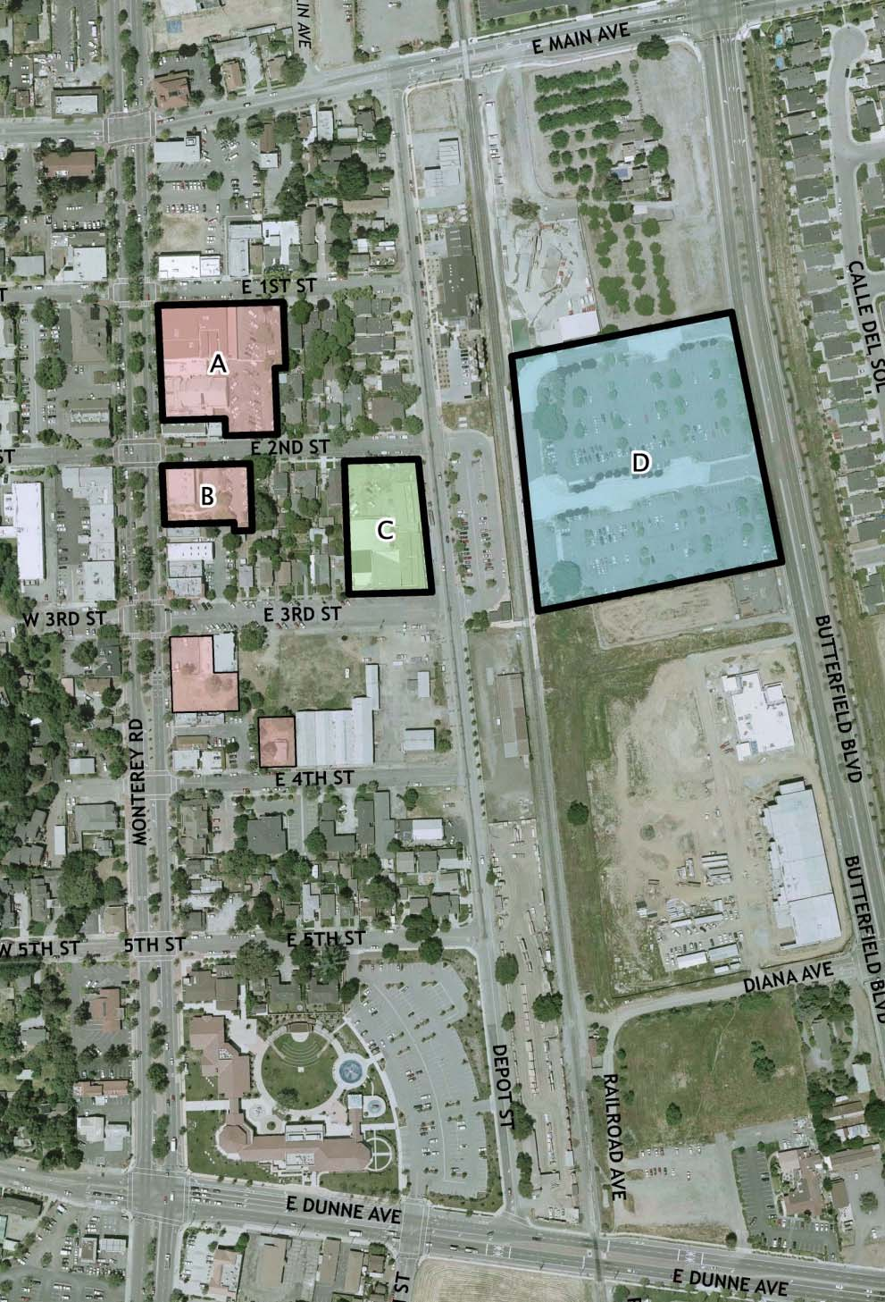
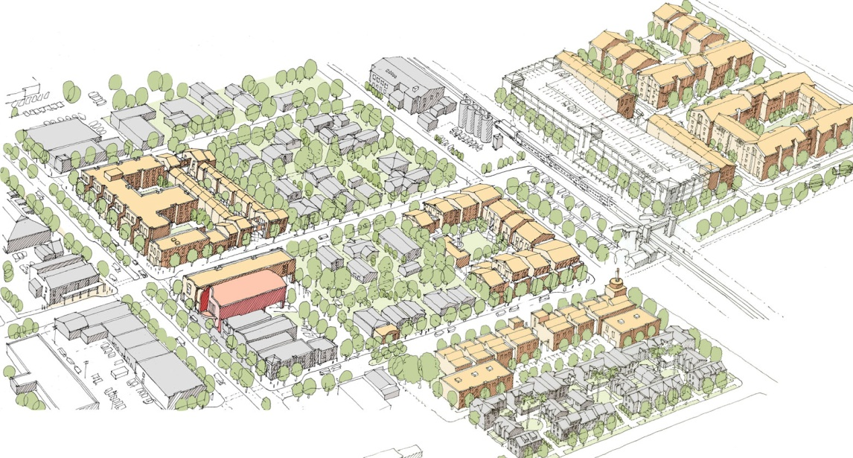

Figure 8 – WRT/Solomon ETC Architects: Maximum Capacity Study
SITE | ACRES | OWNERSHIP | EXISTING USE | DEVELOPMENT REQUIREMENT | NOTES
A | 1.47 | Agency | retail, residential and parking | Retail, residential
B | 0.51 | Agency | retail, parking and pocket park | Cinema, retail, public parking | Also potentially office space
C | 1.08 | Private | retail and parking | Retail, residential | Also potentially office space; must secure site control
D | 6.89 | VTA / Agency | parking for commuter rail | Residential, commuter parking | Potential office &/or retail also; must secure site control

Responding developers are encouraged to select the site or sites that they consider best suited in their judgment for their proposed first phase project.
The Agency has assembled and owns the two sites (A & B) on Monterey Road in the downtown retail core. Although the intent of this RFQ is to solicit developer interest in any or all of these sites, the Agency has identified Site B as a likely first phase project given current market conditions, and especially in light of the first phase desire to re-establish cinema in downtown, as an anchor to expand retail customer traffic.

B. Block 2: Site A
Site A is approximately 1.5 acres bounded by Monterey Road, East First Street and East Second Street and is 100% Agency-owned. The existing Granada Theater occupies a portion of this site. The Agency commissioned two renderings of this site in order to help inform the community as to what a potential project might look like on this site. These renderings are immediately below.
Figure 9a – Monterey Road at East First Street (looking southeast)
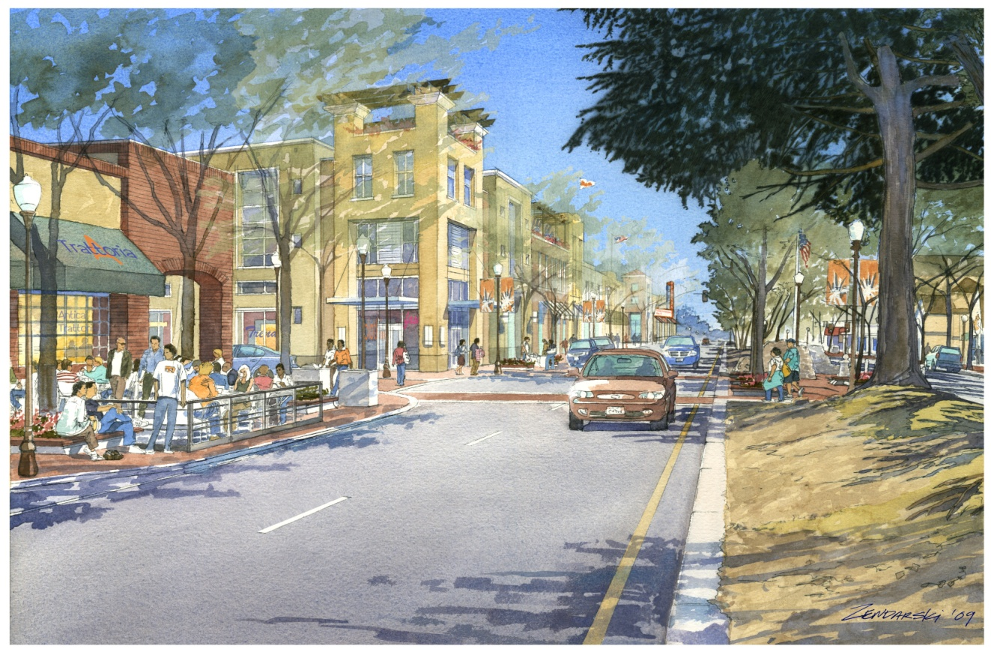

WRT/Solomon ETC developed a design that included approximately 20,000 square feet of retail space, 70 housing units, 110 parking spaces for the units and one level of subterranean parking that yields approximately 160 public spaces.
In order to accelerate the re-establishment of cinema in downtown as a magnet anchor-use to draw residents and visitors to downtown, the Agency has allocated $310,000 toward the costs of temporarily re-opening the existing Granada Theater on an interim basis should the first phase cinema project include relocation of the Granada.

Figure 9b – Monterey Road at East Second Street (looking northeast) – historic Votaw Building on corner
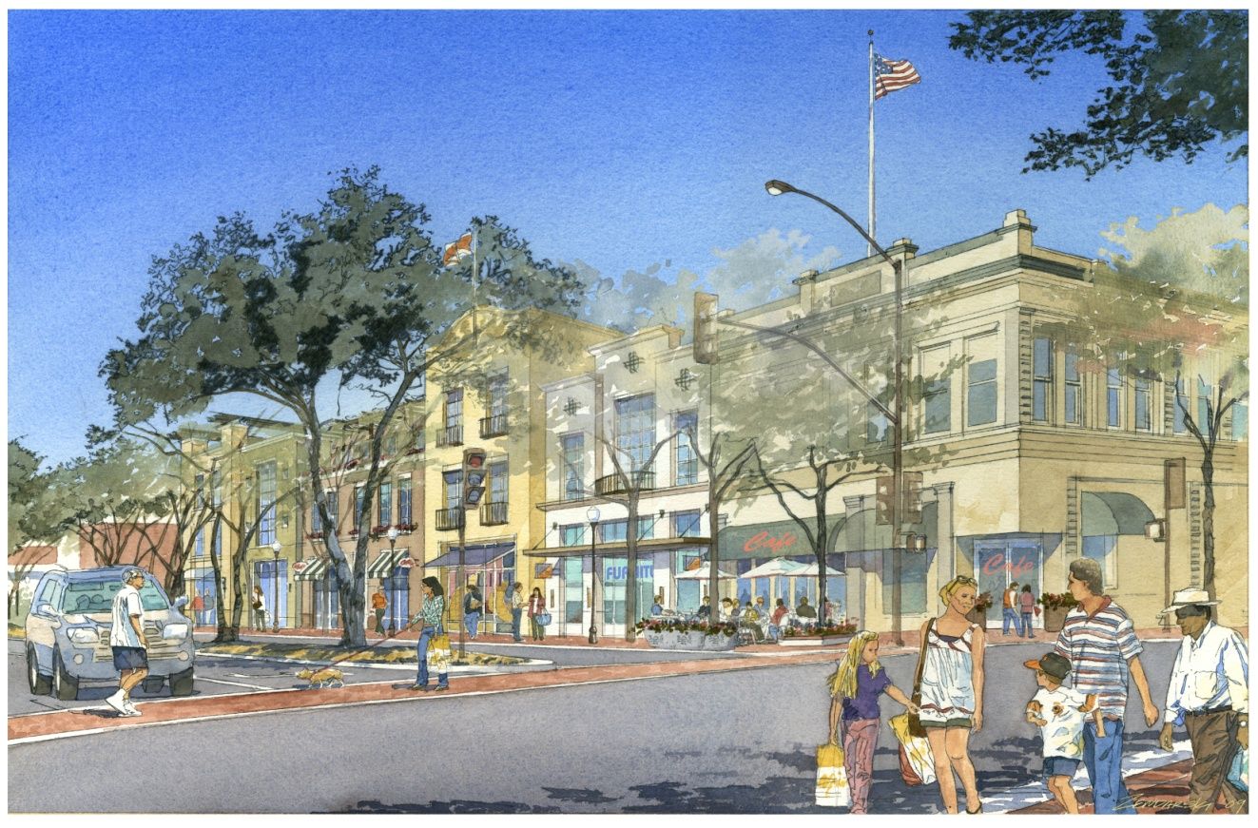

Although the City’s historic consultant determined that the existing Granada Theater did not meet the criteria for National, State or local historic designation, the City Council nevertheless designated the Granada Theater sign and marquee as components of the Granada that must be retained, and therefore, incorporated into a downtown development project.
All of the existing residential and commercial tenants on this site are occupying their spaces or units on month-to-month lease agreements. Five of these tenants may be eligible for relocation benefits.

C. Block 3: Site B
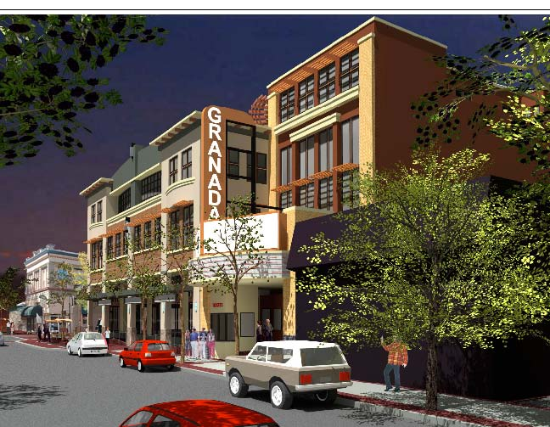
Figures 10a and b – Concept Design (Henry Architects)
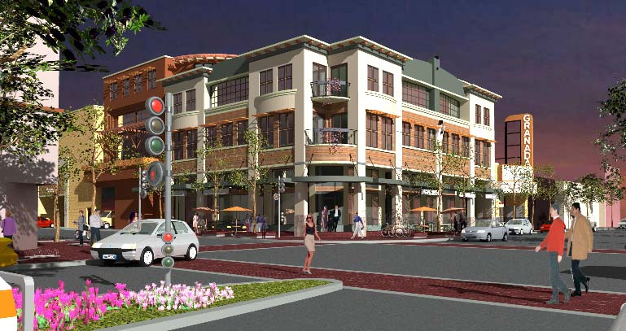
Site B is approximately 0.5 acre bounded by Monterey Road, East Second Street and East Third Street and is 100% Agency-owned.
The Agency has identified Site B as the most likely first phase project given current market conditions, and the first-phase goal of re establishing cinema in downtown.

The Agency commissioned Henry Architects to develop a conceptual design of a mixed-use retail, cinema, office and residential project on this site. Two renderings are displayed here. The full set of development drawings is attached as Exhibit C. The Henry design includes 5,900 square feet of ground floor retail space, a 4screen 477 seat cinema on the second floor with a ground floor entrance on Monterey, 11,100 square feet of office space on the second and third floors plus three “optional” residential condominium units (1700, 2300 & 2500 square feet) on the fourth floor

Responders are encouraged to review these materials as they were created to help inform what might constitute the components of appropriate development on Monterey Road. Notwithstanding the Henry Architects design, the Agency urges each responder to provide their unique professional perspective on the feasibility of this concept. Responders are not expected to submit any concept site plan or elevation drawings at this RFQ stage.
The existing tenant on the site is on a month-to-month lease agreement and may be eligible for relocation benefits. The existing City “pocket park” would be eliminated by any proposed development. All or most of the rear public parking area is intended to remain as a public parking resource, although the air space above the parking would be suitable for development (in a manner similar to the Henry Architects concept design).

D. Block 3: Site C
Site C is approximately 1.1 acres bounded by Depot Street, East Second Street and East Third Street, and is privately owned. This site contains a mix of retail and commercial businesses in approximately 25,000 leasable square feet. As part the development program developers of this site would be expected to address business relocation elsewhere downtown, or temporary relocation and on-site reestablishment of these current businesses.

E. Block 16: Site D
Site D is approximately 6.89 acres at mid-block of Butterfield Boulevard, east of the Union Pacific Rail Road / CALTRAIN commuter rail line, and owned jointly by the Santa Clara Valley Transportation Agency (VTA), as 59% majority owner, and the Agency, as 41% minority owner. Should a developer propose and the Agency select Site D to pursue as a result of this RFQ, the Agency will assist with the necessary agreements with VTA. Maintaining sufficient parking for the Caltrain / VTA services would be required under any development proposal on this site. The new Courthouse is located just south of this site.

F. Site Assembly
[If the RFQ is issued by a Redevelopment Agency, clarify if additional site assembly will be considered.]
The Agency does not have eminent domain authority for assembly of sites which could then be offered for private development. A prospective developer that proposes a project that includes property not owned by the Agency will be required to take the lead in negotiating and securing site control with the applicable property owner after ratification of the ENA.
The private or public ownership entities for Sites C and D have advised the Agency of their interest in discussing the options for development of their sites either through a sale, joint venture or other creative agreement. Agency staff is available to facilitate these discussions as requested. Once site control is secured, the Agency would initiate negotiations towards completing an Owner Participation (OPA) agreement for non-Agency owned properties.
Respondents are requested not to contact private property owners during this solicitation process and to observe these conventions in formulating proposals:
- For sites A & B, which are owned by the Agency, assume they will be acquired in fee by the developer. All Agency sites will be sold “as-is”.
- For site C, which is privately owned, assume the property will be acquired via sale, joint venture or other creative agreement by the developer.
- For site D, which is jointly owned by the VTA and the Agency, assume this property will mostly likely be acquired by the developer via a ground lease. Should this site be included in the selected first phase project, standard VTA development procedures and will likely require a Request for Proposals (RFP) phase after this RFQ phase, prior to the ENA phase.

VII. OTHER SITE AND PROJECTS DOWNTOWN

A. Block 3: 45 East Third Street
City staff is in discussion with the owner of this home to create a mixed use retail and upper floor residence as a street-front addition to the existing home. If agreement is reached and a development program consistent with the Plan is developed, this project could serve as the first new development on the Third Street Promenade.

B. Block 4: Agency-owned property and Sunsweet Site
The two Agency-owned sites, one at Monterey and East Third Street, and the second at East Fourth Street, could potentially be combined with other privately owned property on Block 3 to create a feasible project. The largest of these sites is the 2.5 acre privately- owned site bounded by East Third Street, Depot Street, and East Fourth Street, commonly known as the Sunsweet site.

C. Block 7: Weston-Miles
This 1.0 acre site, bounded by Depot Street, East Main and the UPRR line, appears suitable for a residential, a mixed-use (residential with ground floor retail) or a live/work project.

D. Block 15: Huntington Square
This 6-acre site, bounded by East Main Street, Butterfield Boulevard, Site D (VTA/Caltrain) and the UPRR line, has been approved for 134 luxury town-homes. The first phase construction of 14 units is underway. The project currently has 99 dwelling unit allocations through the RDCS process. The developer is in discussions with the Agency to purchase the adjacent concrete batch plant site, which is owned by the Agency. The batch plant is required, under the terms of the Agency purchase of this site, to close and move operations no later than December 2010.

E. Block 18: EAH & South Bay Development
This 3.1 acre site is planned for a total of 80 units: 40 units of affordable senior apartments and 40 units of market rate townhouses. The project has its RDCS allocations and the developer of the 40 affordable units is applying for tax credit financing from the State.

F. California High Speed Rail
In July 2008, the California High-Speed Rail Authority selected Pacheco Pass as the preferred corridor and alignment for the proposed High Speed Train service (HST). The preferred alignment for HST through Morgan Hill is currently on grade separated tracks located on or adjacent to the UP railroad tracks through downtown. As currently proposed the nearest stations would be in San Jose and Gilroy, although a number of proposed alignment alternatives and station locations are expected to be analyzed over the next 3 years. However, the City of Morgan Hill has recommended the EIR/EIS process include design options for an alignment through Morgan Hill along U.S. Highway 101, which is Morgan Hill’s preferred alignment.

VIII. SUBMITTAL PROCESS: DEADLINE, REQUIREMENTS & REVIEW
[The core of the RFQ – deadlines, submittal requirements and review process.]

A. Deadline for Submissions
All submissions must be received at the address below no later than 4:00 p.m. PST December 14, 2009. Only hard copies will be accepted. Electronic or fax copies will be rejected. RFQ submittals are to be delivered to: City of Morgan Hill, City Clerk’s Office, 17555 Peak Avenue, Morgan Hill, California 95037.
Please provide ten (10) complete sets plus one (1) electronic CD version of the information requested below. Please organize your submittals into sections separated by identification tabs with the same titles as those provided below. The Agency reserves the right to request additional information from responders following review of the information submitted.

B. Requirements for Submissions
The following is requested in order for the Agency to evaluate the experience and capacity of the developer to undertake the proposed project.

1. Transmittal Cover Letter
Please address the letter to:
David Heindel, Assistant to the City Manager City of Morgan Hill 17555 Peak Avenue Morgan Hill, California 95037
The transmittal letter should include the following information:
- Name, address, telephone and fax numbers, etc. for the lead development company.
- Name, title, address, telephone number, fax number and email address of the person designated as the primary contact for the lead development company.
- Legal structure of lead development company or anticipated entity (e.g., corporation, joint venture, limited partnership, etc.) and date of legal establishment.

2. Development Team Summary
The development team could consist solely of a developer and the Agency does not expect that respondents can at this time identify all the professionals that might eventually be involved in the project. However, to the extent that a more comprehensive set of team members can be identified (e.g., architect, consultants), please do so by providing the following information on each member of your team.
- If the lead development company has already identified outside consultants or advisors to assist in the Planning, design, negotiations, or other aspects of the project, please identify these consultants/advisors and briefly describe the nature and type of service to be provided and a description of the roles of key team members plus one-to-two page resumes of relevant staff assigned to this project.
- Description of core business activities
- Number of years in business
- Number of full-time employees
- Supplemental materials, such as company brochures, etc.
- List of any commercial properties or development sites in Morgan Hill currently owned or controlled by developer or any of its identified team members

3. Proposed Site or Sites and Project Concept
The Agency is interested in an RFQ response that provides a project concept that meets the Agency’s goals and criteria in unique and innovative ways. The Agency expects that the developer’s concept would not need to include any detailed design drawings (e.g., site plan, floor plans, elevations or renderings), and that should the responder identify more than one site or phase, that only an even more limited description of future phases would be expected.
Responders are nevertheless encouraged to submit as much detail as they deem appropriate in order for the Agency to clearly understand the project.
That Agency has identified the following items that responders may want to incorporate, to the extent possible and appropriate at this RFQ stage. The Agency acknowledges that responders may not be able to provide all or complete descriptions for all of the points listed below:
- Overall project narrative that identifies the proposed site or sites and gross value of proposed development
- A summary of the proposed process for community engagement and involvement
- List types of uses (e.g., office, retail, residential, etc.) including building area (gross) by
- uses and how the project relates to Plan objectives and supports Agency goals
- Describe the scale of development including building heights and massing, articulation of ground-level retail spaces and relationship to the public sidewalk
- Provide an estimate of total square feet of residential uses, leasable square feet of retail space, leasable square feet of entertainment/cinema space (if applicable), and leasable square feet of office space (if applicable)
- Articulate the marketing focus of the residential units and how that market focus might be reflected in unit type, project features and price point.
- Articulate a retail development strategy, including location of key uses, size/distribution of tenant spaces, interrelationship with parking resources, identification of illustrative tenancies, and related factors.
- Provide an estimate of the number of housing units (if applicable) and if possible a breakdown of the mix of units with number of bedrooms and bathrooms, plus amenities
- Provide an estimate of the number of on-site private and on-site public parking spaces and their location.
- Describe potential green building features that might be incorporated into the project.
- If applicable, describe potential phasing issues/concerns, and construction staging.

4. Relevant Development Experience and Development Capacity
[This is a critical section as it provides detail regarding the developer’s expertise and prior experience.]

Please provide a description of no more than three relevant projects completed or in process by the development team. Members of the proposed development team for the proposed project should have had a significant role in these past projects. For each project, please include the following, as applicable and to the extent possible and appropriate:
- Project name, location and type of real estate product
- Description of the real estate product, its quality and amenities
- Experience in developing community consensus and securing community support for the project
- Current status of the project (i.e., construction status or number of years since completion)
- Photos and site plans of the project
- Names and roles of other companies, organizations, or partners involved in the project
- Development cost and financing summary
- Primary sources of equity and debt
- Primary sources of cash or cash equivalents employed during pre-development
- List of lenders for the project including contact name, phone number and email address
- Indication of whether the project involved a ground lease
- Indication of whether the project involved a business relationship with a public agency and a description of the nature of any such relationship

5. Demonstration of Financial Capacity and Related Information
[It is essential to know the financial strength of the developer and/or development team. Recognize the sensitivity for the developer in providing this information and make sure you have procedures to protect confidentiality.]

Please provide the following information to demonstrate the financial capacity to undertake and complete the development proposed in the Proposed Site or Sites and Project Concept section. Developers shall mail or deliver one (1) bound original of the Evidence of Financial Capacity, Section 5 of the RFQ (which shall remain confidential) under separate cover by the same date and time to: Tim Kelly, Keyser Marston Associates, Inc., 55 Pacific Avenue Mall, San Francisco, CA 94111. This information will be used solely by them for purposes of evaluation under the RFQ and will be treated as confidential to the extent allowed by law. This one original will be returned at the conclusion of the selection process with no copies retained by the City / RDA.
- Financial Statements for the previous three fiscal years for the lead development or team members (as applicable). Certified statements are preferred.
- Most recent annual report(s).
- List of any current non-performing loans or loan defaults in the past five years
- Description of instances in which a member of the development team or any named individual has been involved in litigation or other legal dispute regarding a real estate venture during the past five years. Include information regarding the outcome of the litigation or dispute
- Information about instances in which any member of the development team has ever filed for bankruptcy, or any projects that have been lost to foreclosure
- Past history of raising capital
- Composition of real estate portfolio by type and occupancy percentage
- Any available evidence that demonstrates that the development team has the financial capacity to engage in the planning and development of the site or sites, specifically, (1) balance sheets detailing cash or cash equivalent funds sufficient to fund necessary pre-development activities pursuant to an ENA, and (2) evidence of financial capacity to carry out the development of the proposed site or sites.

6. References
[Ask for a range of references and check them. Make sure references are provided for the type of project you’re seeking, and make sure they’ve worked with the public previously.]

Provide references with sufficient information to ensure easy contact. This should include company/organization, names, titles, telephone numbers, and email addresses for individual who can provide information relating to the following items:
- Financial Contacts – Identify at least three contacts that have provided members of the development team with debt or equity financing of at least the magnitude likely to be required for the proposed project.
- Public or Government – Identify at least two redevelopment agency, county, city or other public officials who have been involved with a project completed by members of the development team (e.g., city managers, redevelopment staff, Planning directors, economic development directors, etc.).
- General – Provide the names of up to two other contacts that could provide information about the experience and capability of members of the development team for a program of the magnitude proposed.

C. Submittal Schedule
- September 29, 2009 – Release of this RFQ
- October 21, 2009 – Site Visit (optional); Deadline to submit questions / clarifications
- October 29, 2009 – Question responses distributed
- November 4-6 – Second Site Visit (possible – to be confirmed)
- November 9-13, 2009 – Informational meetings with individual proposers (optional)
- December 14, 2009, 4:00 pm PST – Deadline to submit responses to RFQ

IX. EVALUATION CRITERIA AND SELECTION PROCESS
[Notice how the RFQ evaluation criteria focus on experience and financial strength. This is what distinguishes an RFQ from a Request for Proposal (RFP).]

A. Evaluation Criteria
The submittals will be analyzed based upon, but not limited, to the following criteria:
- Direct relevant qualifications and experience of the development team
- General qualifications of team members
- Compatibility of proposed sponsor and project with Agency objectives
- Quality and financial performance of past projects
- Experience with similar high-profile mixed-use (retail/office/residential) public-
- private projects with significant community input conducted in partnership with a redevelopment agency
- Demonstrated successful experience of the development entity (not consultants to that entity) in negotiating complex real estate transactions with public entities

- Financial capability of development team including lender references
- Demonstrated ability to raise debt and equity for a project of the magnitude that is being proposed
- Strength of relationships with financial institutions
- Overall financial track record and capacity
- Litigation and bankruptcy disclosures

B. Selection Process
[Often the selection of a developer or developers via an RFQ then leads to the submission of a proposal for final determination. So an RFQ can be the initial stage leading to an RFP, or you may just proceed with the developer.]

The Agency intends to form a Community Review Committee prior to conclusion of the submittal deadline in December 2009. The Community Review Committee will identify any additional information that might be requested of responders as well as comment on the strengths and weaknesses of a short list of proposals. The Committee and Agency staff may conduct interviews of selected responders including presentations of the materials submitted, but the Agency does not currently expect that responders will be required to make a public presentation.
In the event that there are a sufficient number of proposals received or in the event of responses for Site D (Block 16: VTA), the Agency may consider undertaking the additional step of a Request For Proposals (RFP) process prior to selecting a developer candidate. The RFP process will allow the Agency to select a short list of responding developers, who will be invited to submit a more detailed proposal.
The Review Committee’s comments will be forwarded to the Agency Board for its consideration along with the Agency Executive Director’s recommendation for the selection of the preferred developer. Final developer selection will be subject to approval by the Agency Board.

X. POST SELECTION PROCESS AND FUTURE MILESTONES
Upon Agency Board selection of a preferred developer partner, Agency staff will begin the process to complete an Exclusive Negotiating Agreement (ENA) with the selected developer, followed by negotiation in the case of Agency-owned property of a DDA, or in the case of privately-owned property, an OPA, once the developer has demonstrated the necessary site control.
For Agency-owned sites and upon approval of the ENA by the Agency Board, the selected developer will be required to submit a deposit in the form of a cashier’s check made payable to the Morgan Hill Redevelopment Agency in an amount equal to fifty thousand dollars ($50,000) to assure performance by the developer under the terms of the ENA. The Agency will return this deposit at such time as the developer provides satisfactory evidence to the Agency that the developer has incurred qualified pre-development costs associated with the ENA of not less than $100,000. Qualified costs exclude developer staff or legal services. The selected developer will be responsible for all costs and expenses that the developer incurs during the ENA period, except as the Agency may agree otherwise, in writing.
The DDA will identify and describe all responsibilities of the developer and the Agency and finalize all business terms between the Agency and the developer concerning the proposed development. The ENA and DDA will include detailed Milestone Time Frames for project phases including, but not limited to, design development, entitlement, permitting, financing, and start and completion of construction.
FUTURE MILESTONES (preliminary target dates, these estimates are subject to change)
These are the steps in our process, which may be modified as required, at the sole discretion of the Agency. These timeframes assume that the intermediate RFP process is not required.
- January/February 2010 – Agency Board preliminary consideration of recommended preferred developer
- March 2010 - Agency Board final consideration of ENA (start of DDA or OPA negotiations)
- July 2010 – Agency Board to tentatively approve conceptual design, development program and business terms, including Agency financial role
                - September 2010 – Design Review permit submitted (assumes no additional supplemental environmental review beyond the MEIR)
- November 2010 - Agency Board final consideration of DDA (or OPA)
- Spring/Summer 2011 – construction start for phase one project
- Fall/Winter 2012 – construction end for phase one project

XI. DISCLAIMERS, LIMITATIONS AND WAIVER OF PROTEST
[The small print. It is important to note that usual RFQ processes allow the grantee broad discretion to terminate the process or not select any firm via the RFQ. The grantee should ensure broad discretion to act in the agency’s best interests.]

By responding to this RFQ, each proposer voluntarily and knowingly agrees as follows:
- All numbers in this RFQ are approximate. Although deemed to be secured from reliable sources, responders will independently confirm any and all numbers to their satisfaction.
- Selection is at the sole discretion of the Agency.
- It is conceivable that different developers could be selected for different sites.
- The Agency may amend or terminate selection procedures at any time at its sole discretion.
- The Agency is not obligated to enter into any agreement with any entity as a result of this process or provide any assistance (financial or otherwise) to any entity.
- The Agency is not, under any circumstances, responsible for costs borne by proposers for preparing responses to this solicitation, or any costs associated with the selection process. Each proposer shall bear its own such costs. Each proposer shall hold the Agency harmless from any and all liability, damage, claim, loss and/or expense incurred by or on behalf of such proposer in connection with or relative to this RFQ.
- The Agency will not pay a finder’s fee / brokerage fee to any entity representing or purporting to represent proposers. Each proposer shall hold the Agency harmless from any and all liability, damage, claim, loss and/or expense incurred in connection with or relative to any such fee.
- All materials submitted in response to this solicitation will become the property of the Agency. The California Public Records Act (California Government Code Sections 6250 et seq.) mandates public access to government records. Therefore, unless the information is exempt from disclosure by law, the material submitted may be made available to the public. Any material that responders wish to be maintained as confidential must be clearly marked “CONFIDENTIAL”.
- The Agency assumes no responsibility for delays caused by delivery service. Postmarking by the due date will not substitute for actual receipt by the designated due date and time.
- By submitting a response to this RFQ, each proposer expressly waives any and all rights that it may have to object, protest or seek legal remedies whatsoever regarding any aspect of this RFQ, including without limitation, the Agency’s selection of a developer, the Agency’s rejection of any or all submittals and any subsequent agreement that might be entered into as a result of this RFQ.
Proposers are cautioned not to contact members of the Agency Board during this selection process, apart from interface that is structured by Agency staff; doing otherwise may result in disqualification of proposer.
The Agency reserves the right to modify, suspend, or terminate at its sole discretion any and all aspects of the RFQ process. The Agency also reserves its rights to obtain further information from any and all responders submitting qualifications and to waive any defects as to form or content of any responses.

XII. CITY CONTACT FOR QUESTIONS
For questions pertaining to this RFQ, please contact [Insert staff contact name] Assistant to the City Manager: email [staff.contact@agency.gov]; phone: [555-555-5555]; fax [555-555-5555].
Send ten copies plus one (1) electronic CD copy of submittal to:
City Clerk’s Office City of Morgan Hill 17555 Peak Avenue Morgan Hill, California 95037 Main: (408) 779-7271 Fax: (408) 778-7869
The proposal packages must be received no later than December 14, 2009. Submittals received after 4:00 PM PST on that date will not be accepted. Faxes or emails will not be accepted.
We thank you for your participation!

XIV. LIST OF EXHIBITS
(also available on City web site at www.morganhill.ca.gov/downtown)
A. Capacity Studies (WRT/Solomon ETC Architects)
B. Concept Renderings for Site A (Art Zendarsky)
C. Concept Design Drawings for Site B (Henry Architects)
D. Engineering Survey – Block 2, Site A (Chappell Engineers)
E. Engineering Survey – Block 3, Site B (Chappell Engineers)
F. City-wide & Downtown Retail Strategy (Workshop, January 20, 2009)
G. Ground Floor Overlay District (Downtown Specific Plan)
H. Letter of Interest (CineLux Theatres Co. LLC)

XV. RELATED REFERENCE MATERIALS
(available on City web site at www.morganhill.ca.gov/downtown)
- Downtown Specific Plan (RBF Consulting’s Urban Design Studio)
- Master Environmental Impact Report (David J. Powers Associates and Fehr &
- Peers, traffic consultant)
- General Plan Circulation Element Amendment and Draft EIR
- Ballot Measure A, May 19, 2009
- Parking Resources Management Strategy (DKS)
- Phase 1 Environmental Site Assessments (Site A)
- Phase 1 Environmental Site Assessments (Site B)
- Demographics
- City Down-Payment Assistance Program
- For-Sale Housing Market Data
- Apartment Survey: historic rental rates and vacancy
- Green Building Ordinance
- Redevelopment Agency Board / Planning Commission Joint Workshop: 1/20/09

