Sample Clean & Green Maintenance Program Guidelines

About this Tool

Description:
These sample Clean and Green maintenance program guidelines are intended to assist a land bank in the creation and implementation of a Clean and Green program. Clean and Green is a maintenance program that involves using community groups to help maintain properties. It is a win-win program for both the land bank and the community.
How to Adapt this Document:
This document should be used as a guide for creating and implementing a Clean and Green program that meets the needs of the land bank. It addresses the major land bank categories that should be included at a minimum. However, it should not be used as-is and should be altered to meet the goals of the individual land bank program.
Source of Document:
Substantial portions of this document come from a document utilized by the Genesee County Land Bank Authority.
Disclaimer:
This document is not an official HUD document and has not been reviewed by HUD counsel. It is provided for informational purposes only. Any binding agreement should be reviewed by attorneys for the parties to the agreement and must conform to state and local laws.

This resource is part of the NSP Toolkits. Additional toolkit resources may be found at www.hud.gov/nspta

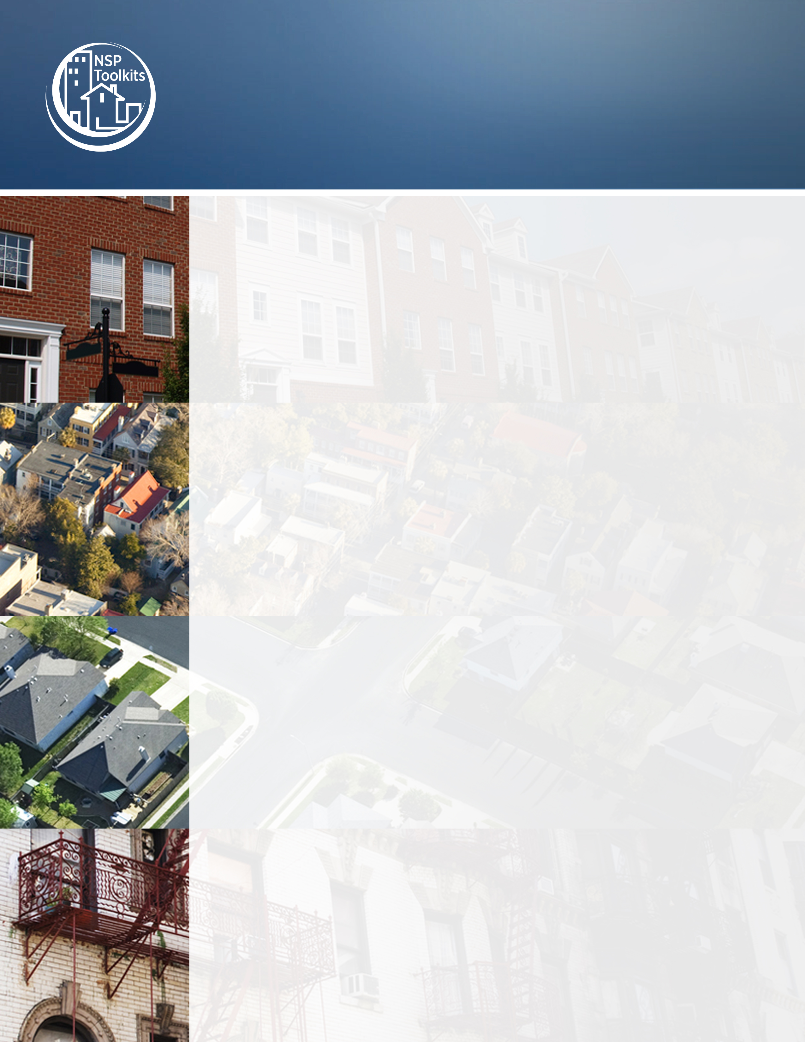
U.S. Department of Housing and Urban Development Page 1
Neighborhood Stabilization Program

Clean and Green Program Guidelines

Land Bank’s Clean and Green Program supports innovative community groups and organizations in the cleaning, maintaining, and beautifying of Land Bank owned properties.

Groups looking to participate in this year’s Clean and Green Program will go through a competitive application process. In selecting groups or organizations to participate in the program, the Land Bank will look to those with the following characteristics:

- Strong ties to the neighborhood or area in which work will be performed
- A commitment to including area youth as part of the program
- Past experience in clean-up and/or neighborhood beautifying activities
- A well-organized work team structure
- Access to tools and equipment needed to perform work
- Creative and thoughtful plan regarding the beautification and greening of properties, with a focus on vegetable gardening and/or fresh food generating greening activities
- Capacity to acquire liability insurance to cover each individual performing work or willingness to have each participant sign a liability release form
- Resourcefulness (i.e. leveraging funds from other sources)

Program Details
- Participants are required to:
- Maintain at least (number) Land Bank properties
- Develop at least (number) gardening project(s)

- All applicants will be competing for available project funds. Allocation of project funds will be determined by:
- Geographic size of area
- Number of Land Bank properties in area
- Group’s capacity for community outreach and maintenance
- Groups goals as outlined in the attached application
- The number of gardening projects a group is willing to complete

- Gardening Projects are required to be developed by each Clean and Green group. Groups are strongly encouraged to include vegetable gardens and to involve area youth as part of their garden projects. The location of these gardening projects as well as details of what the projects will entail will be determined before the start of the work period. Besides vegetable gardens, gardening projects may include:

- Flower gardens
- Decorative fencing
- Tree planting
- Low maintenance plantings
- Signage

- Participants in this program will be chosen using a competitive application process. In the attached application, groups will have to provide a budget detailing the use of Land Bank funds being applied for as well as provide a description of other sources of funding they are seeking (i.e. beautification grants).

- Program Timeline
- Clean and Green applications are due by _____, 20XX
- Land Bank staff and advisors will review applications
- Selected groups will be notified by ____,20XX
- Representative(s) from selected groups will meet with Land Bank staff to inventory property to determine exact location and condition
- Signing of a memorandum of agreement between group and Land Bank
- Groups are expected to begin work in mid (month), with full youth participation beginning at the end of the school year
- At least (number) rounds of maintenance must be performed on each property before the end of the program (mowing, trimming, light brush removal, and litter pick-up)
- Program ends in _____, 20XX

The Land Bank looks forward to working with community-based groups to improve the appearance of neighborhoods through the Clean and Green program. Those groups interested in participating in the program should fill out the attached Clean and Green application form.

